THE BRITISH UNIVERSITY IN DUBAI
CSAI-413: Natural Language Processing Applications

Deliverable 1 Report
UAE Labour Law Intelligent Assistant
A Retrieval-Augmented Generation (RAG) System

Course | CSAI-413: Natural Language Processing Applications
Submission | Deliverable 1 | Week 6 | May 2026

1. Problem Definition

As UAE's labour laws and employment legal regulations have become more complex, there is an increasing demand for intelligent systems that can help users get accurate, reliable and context-relevant information. The vast amount of documentation and the legal jargon associated with it can cause confusion for employees and employers regarding labour policies and procedures, such as understanding the definition of annual leave, working hours, termination conditions, the calculation of a gratuity, rights at work and complaints.
Conversational chatbots and keyword-based search systems are often inadequate at making accurate legal judgments since they are trained to match keywords or use as much of their internal language model memory as possible to make a response without taking into account authoritative legal sources. Therefore the answers produced may be factually inaccurate, legally untraceable or contextually irrelevant, particularly in the case of domain-specific legal questions.
This project aims to create a UAE Labour Law Intelligent Assistant based on a Retrieval-Augmented Generation (RAG) architecture to tackle these challenges. This system involves semantic retrieval and Large Language Model (LLM) generation, generating grounded answers from official documents linked to the UAE labour law from trusted governmental websites such as the UAE Legislation Portal and the Ministry of Human Resources and Emaratisation (MOHRE). The system will be able to retrieve chunks of legally relevant information from a semantic vector database before generating the response—this will improve the accuracy, contextually responsible, and legally justified response from the assistant. The Retrieval-Augmented Generation method is effective in improving factual coherence as well as reducing the hallucination phenomenon by acting as a basis for generating answers from legal evidence.The RAG system is also superior in terms of avoiding hallucination when generating responses, as compared to standalone LLM systems, because it builds a more coherent and reliable response by relying on the retrieved legal evidence.
The main goal of this project is to build a light-weight legal intelligence assistant that is able to assist semantic legal question answering in UAE labour law domain. The system also applies Natural Language Processing (NLP), semantic search, vector embeddings, and AI generation methods for documents in a real-world legal information retrieval problem.

2. Dataset Description

2.1 Dataset Collection and Legal Document Organization
The initial phase of the project involved building a structured and reliable legal dataset to feed into the Retrieval-Augmented Generation (RAG) pipeline.The first part of the project was on building a structured and reliable legal data set to feed to the Retrieval-Augmented Generation (RAG) pipeline. The data preparation process included data collection, validation, structuring and categorisation of official data of labour related legal documents from trusted UAE governmental data sources.

Data Sources
Only official websites of the UAE government have been used to obtain the legal documents that are included to make sure they are authentic and legal. Primary sources included:
- UAE Legislation Platform
- Ministry of Human Resources and Emiratisation (MOHRE)
- Official UAE Government Labour and Employment Portals

The collected documents included federal decree laws, cabinet resolutions, executive regulations, employment policies, worker protection regulations, labour dispute procedures, occupational safety guidelines, Wage Protection System (WPS) documents, domestic worker regulations, remote work policies, end-of-service benefits documentation, work permit regulations, and employment contract and leave policies.

Dataset Structuring and Categorization
To improve document retrieval efficiency and semantic relevance, the dataset was manually organized into the following thematic categories:

Folder | Contents
Core_Laws | Primary UAE labour laws and executive regulations forming the legal foundation of the assistant.
Employment_and_Work_Models | Employment contracts, work permits, remote work models, labour market policies, and employment-related operational regulations.
Worker_Protection_and_Safety | Occupational health and safety regulations, wage protection system documentation, labour camp awareness materials, and worker rights protections.
Disputes_and_Complaints | Labour dispute procedures, complaint handling regulations, termination policies, and employment conflict resolution documentation.
Awareness_and_Guides | Awareness guides, informational brochures, employee guidance materials, and public explanatory labour documents.
Additional_Laws_and_Regulations | Supplementary legal regulations and supporting governmental resolutions related to employment and labour governance.

Challenges and Considerations
The following were considered during the preparation of the datasets: documents from official government sources in UAE, elimination of repetitive and outdated regulations, organisation of documents by legal function and not by file type, consistent naming of documents and folder structures, and filtering of documents to only include those relevant to employee rights, employer responsibilities and labour procedures.

3. System Architecture

3.1 Overview
The UAE Labour Law Intelligent Assistant has been designed using a modular Retrieval-Augmented Generation (RAG) model. RAG goes beyond just the knowledge in a language model and dynamically fetches relevant evidence from the official UAE labour law documents before producing a response, which is relevant for the legal field. This design has a strong emphasis on the factual grounding and minimizes hallucinated answers.
The pipeline runs sequentially: raw legal documents get cleaned and preprocessed, then split into overlapping chunks and then into vector embeddings representing the semantics of the text and save them persistently in a ChromaDB database. The system performs hybrid retrieval using a semantic similarity search and BM25 keyword search, and then passes the top results from both retrieval methods to a grounded LLM (Gemini) for an answer.

3.2 End-to-End Pipeline Workflow
The following figure illustrates the complete Retrieval-Augmented Generation pipeline implemented for the UAE Labour Law Intelligent Assistant, showing how raw legal documents are transformed into intelligent legal responses.

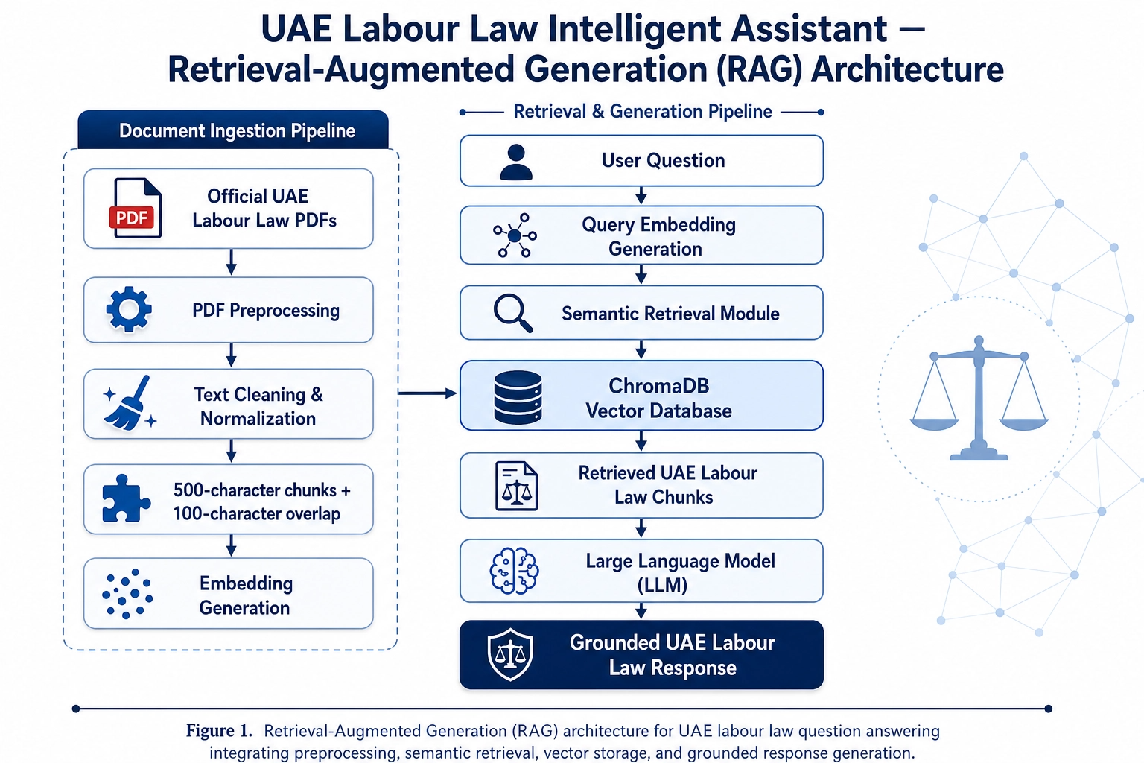
Figure 1: Complete RAG pipeline workflow for the UAE Labour Law Intelligent Assistant

3.3 Modular Components
The system is divided into the following Python modules, each owned by a team member:

Module | Responsibility
data_cleaning.py | Converts raw PDF documents into clean UTF-8 .txt files
ingest.py | Chunks cleaned text, generates embeddings, and populates ChromaDB
retrieval.py | Performs hybrid semantic + BM25 retrieval over stored chunks
generate.py | Formats retrieved context into a prompt and calls the Gemini LLM
app.py | Streamlit web interface that connects all components for end users

3.4 Key Design Decisions
Search by legal questions was done more by means of semantic retrieval than by keywords alone due to the often paraphrased wording of legal questions. An embedded-based search enables the system to find the meaning of the search query. To maintain exact legal keyword matching of terms like gratuity, probation and WPS, hybrid retrieval (70% semantic, 30% BM25) was added. To avoid splitting legal clauses between chunks, a 100 character overlap between chunks was added. Every time you run your app, you won't need to re-generate embeddings, as they are stored locally using ChromaDB.During the development and testing process, you can save computation time by using ChromaDB to store local vectors

4. Design Justification

4.1 Why This Embedding Model?
We chose the all-MiniLM-L6-v2 sentence transformer model for use as an embedding engine for the system for three main reasons. It first creates good quality dense vector representations of each of the 384 dimensions, which contain semantic information, which means that it is able to match legally relevant content even if the user says something different than the exact wording of the content in the law documents. Second, the model can be executed locally without relying on an external API, thus reducing the ingestion pipeline's reliance on networks in the embedding phase. Third, it is smaller than other transformer models like all-mpnet-base-v2 or text-embedding-ada-002, which makes it easy to quickly develop and test.
OpenAI's text-embedding-ada-002 was the main model that was considered, as it generates embeddings of 1536 dimensions, and is renowned for its retrieval capabilities. This was rejected as it would cost, be slow and depend on the network for each chunk during ingestion, as well as for each user query while retrieving. An alternative that was also considered was all-mpnet-base-v2, which generates higher quality embeddings, but is also more computationally expensive. At a much lower cost, all-MiniLM-L6-v2 was able to give us the quality of retrieval needed for such a large project (2033 chunks).

4.2 Why This Retrieval Approach?
To solve this problem, a hybrid retrieval strategy that is a combination of semantic vector search and BM25 keyword search was chosen as the retrieval method to suit the requirement of legal question answering. When the user asks a question in a manner that paraphrases legal concepts, semantic-only search, which matches the meaning of a question to chunks of documents, is more effective for this case with ChromaDB. But it can also break down when it comes to the exact word that you use, such as specific references to articles, defined legal terms such as gratuity and probation, as well as the reference to regulations such as Federal Decree Law No. 33 of 2021, where the keyword is more important than the proximity of the words.
BM25 is a traditional term-frequency based retrieval model which works in a different way – it is very good at matching exact keywords, but it is not good at matching synonyms or rephrasings of the user queries. The hybrid method is a mixture of both with a 0.7 weightage assigned to semantic retrieval and a 0.3 weightage assigned to the keyword retrieval method, which is more beneficial for the semantic retrieval than for the accuracy of legal keyword matching. It is especially suitable for the UAE labour law field where users might want to pose formal and informal queries on the same legal issues.
The alternative of semantic only retrieval was tested informally and was found to yield lower retrieval scores on the procedural questions (such as filing a labour complaint) where the procedural terms are more important than the semantic proximity. Because of this, a dense-only retrieval was not considered and discarded in favor of the hybrid retrieval.

4.3 Design Alternatives Considered
There were a number of other design options that were explored and assessed in the planning process. At first glance, a fixed-size character splitter, with no overlap, was thought to be a simple approach but it was discarded due to its ability to break legal sentences in the middle of a clause, thus spoiling the meaning of the retrieved text for the document chunking task. To maintain sentence and clause boundaries in legal text, recursiveCharacterTextSplitter with 100 characters overlapping was chosen.
To replace the ChromaDB, FAISS was taken into account as a lightweight in-memory solution for the vector store. However, FAISS was rejected due to the absence of a native way to store embeddings persistently on disk within the Python library it was implemented with; this would require re-computing the embeddings each time the system started up. Choosing ChromaDB with PersistentClient meant that the embedding of all documents would be saved to disk automatically, and that there would be a simple Python API, similar to the rest of the pipeline.
The Claude API was designed first based on the project guide template and then adapted for the LLM. After a team review Gemini 2.5 Flash was chosen because it provides a free tier with adequate context window for five returned chunks plus a question, has a restricted prompt input design and has a "retry" feature for temporary API demand errors. The prompt was designed to ensure that the model responds only to the information it has been given in the retrieved chunks, thus not being able to hallucinate information that is not provided in the prompt.

5. Data Cleaning & Preprocessing

In the processing part, the raw PDFs of UAE Labour Law were preprocessed to create clean and machine readable text files for further use in the Retrieval-Augmented Generation pipeline. These raw files were collected from official sources from UAE government and were processed using Python and PyPDF2 library. In the extraction phase the text from every page of the PDFs was merged into a single text file and then multiple cleaning operations were performed on the file.
The data set was subjected to a few pre-processing steps to enhance the quality of the data. Unnecessary formatting things like page numbering, repeating spacing and weird line breaks were removed with regular expressions. The removal of non-retrieval useful URLs and e-mail addresses. Some further whitespace normalisation was done to make sure the formatting of all documents is the same. The text was lastly saved as UTF-8 encoded .txt documents in the data/processed_data/ folder for use in chunking and embedding generation.
Handling inconsistent PDF formatting was one of the biggest problems faced while preprocessing. A small number of documents had incorrect sentence formatting, odd spacing and/or extraction issues due to the PDF format. Some special symbols and inconsistencies in the code were found after extraction, which had to be made after the extraction process in a few cases. A stumbling block in this was the need to preserve key legal content and the need to remove artefacts which were not useful, but which, if too cleaned, could affect retrieval quality later in the pipeline.
The preprocessing pipeline was able to make the documents collected on UAE labour law a clean text data for chunking and indexing, overall. Data cleaning enhanced data readability, noise reduction in the retrieval system, and a more robust basis for embedding generation and semantic search.

6. Chunking, Embedding & Vector Storage

The data ingestion pipeline was implemented in src/ingest.py and is responsible for transforming the cleaned text documents produced by the preprocessing stage into searchable vector representations stored in a persistent local database. The pipeline consists of three main stages: document loading, text chunking, and embedding generation with vector storage.

7.1 Document Loading
Eight .txt documents were loaded from the data/processed_data/ directory using Python's built-in file reader with UTF-8 encoding. Each document was stored as a dictionary containing its text content and source filename, which is later used as metadata during retrieval to identify which document a chunk originated from.

7.2 Text Chunking
We used RecursiveCharacterTextSplitter to break the cleaned documents into smaller chunks with a chunk size of 500 characters and overlap of 100 characters. This splitter respects paragraph breaks, sentence endings and word spaces. This is particularly true for legal documents such as a clause that needs to be unaltered and remain in its original form to have any legal significance. 100 characters overlap guarantees that there won't be any loss of info at the boundary of the chunks. There were eight documents totaling 2,033 chunks.

7.3 Embedding Generation
The all-MiniLM-L6-v2 sentence transformer model was used to transform each chunk into a 384-dimensional numerical vector. It was chosen due to its lightweight nature, no external API required, and its good performance on semantic similarity tasks. All 2,033 texts were encoded in a single batch call using model.encode(texts, show_progress_bar=True), which is significantly faster than encoding chunks one by one.

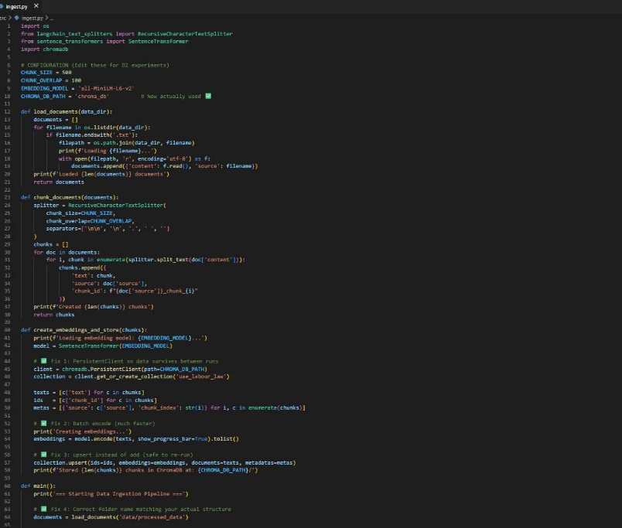
Figure 1: src/ingest.py — document loading, chunking, and batch embedding pipeline

7.4 Vector Storage
All 2,033 embeddings were stored in a ChromaDB vector database using PersistentClient with the path set to the chroma_db/ directory. This saves all embeddings to disk so the ingestion script does not need to be re-run every time the system starts. The upsert() method was used instead of add() to allow the script to be safely executed multiple times without crashing on duplicate chunk IDs.

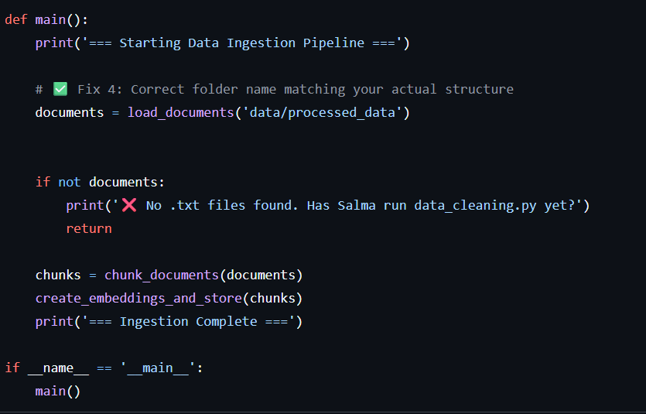
Figure 2: main() function showing the correct folder path, empty-folder guard, and pipeline execution order
Successful execution was confirmed by inspecting the chroma_db/ directory, which contains chroma.sqlite3 and binary index files (data_level0.bin, header.bin, index_metadata.pickle, length.bin, link_lists.bin), representing the persistent HNSW vector index. A verification script src/check_db.py confirmed 2,033 chunks stored in the uae_labour_law collection.

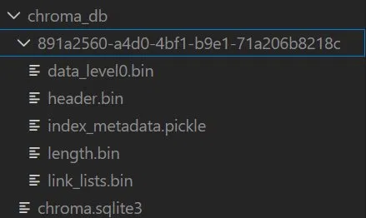
Figure 3: chroma_db/ directory confirming that embeddings were successfully persisted to disk
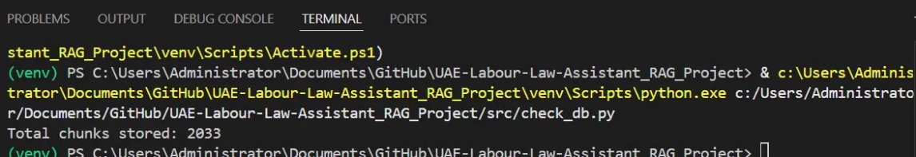
Figure 4: Terminal output of check_db.py confirming 2,033 chunks stored in ChromaDB
The following table summarizes the key configuration parameters used in this stage and the reasoning behind each choice:

Parameter | Value | Justification
Chunk size | 500 characters | Balances context length with retrieval specificity
Chunk overlap | 100 characters | Prevents information loss at chunk boundaries
Embedding model | all-MiniLM-L6-v2 | Fast, local, produces 384-dim semantic vectors
Vector store | ChromaDB PersistentClient | Lightweight, Python-native, saves to disk
Collection name | uae_labour_law | Single collection for all UAE labour documents
Total chunks | 2,033 | Produced from 8 processed documents

7. Hybrid Retrieval & LLM Generation

A user question is fed to the retrieval and generation stage, which pulls the most relevant legal text chunks from the vector database and generates a grounded response with the LLM. There are two files for implementation: retrieval.py to implement hybrid search and generate.py to generate the answer. These two combine to create the primary question answering pathway.

7.1 Retrieval Configuration
All-MiniLM-L6-v2 is the model adopted for the retrieval module for semantic embedding, while five final chunks are returned for generation. Semantic and keyword matching components are given 0.7 weight and 0.3 weight, respectively, with the key-point of giving more weightage to the semantic matching part than to the legal keyword matching part. A tokenization function is used to translate text into lowercase word tokens and strip punctuation to get queries and document chunks ready for BM25 retrieval.
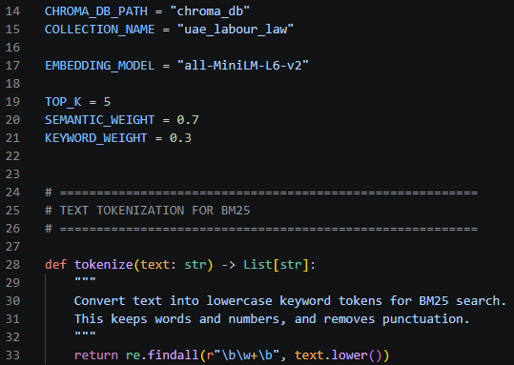
Figure 1: Retrieval configuration and BM25 tokenization

7.2 ChromaDB Loading and BM25 Index
The HybridRetriever class is used to connect to ChromaDB using a PersistentClient, load the uae_labour_law collection, load all the documents and metadata and then tokenise all the chunks and create a BM25Okapi index. The design allows the retriever to perform retrieval using either vector similarity or conventional keyword scoring on the same set of chunks stored in legal.

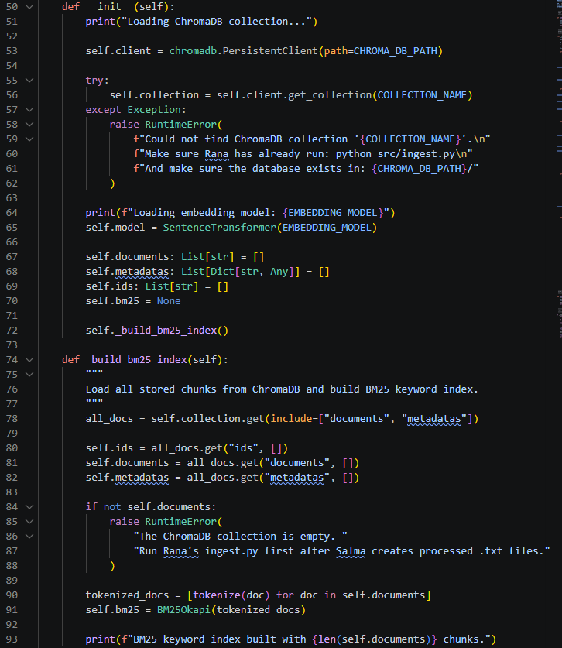
Figure 2: Loading ChromaDB and constructing the BM25 index
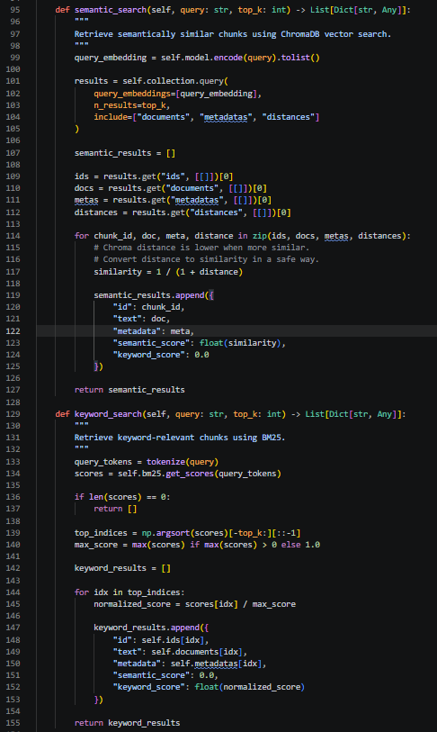
Figure 3: Semantic search and BM25 keyword search implementation

7.3 Hybrid Retrieval Logic
In semantic search, the embedding of the user query is compared to the embeddings of chunks in the database using Chroma distance, which is transformed to 1 / (1 + distance) to yield a similarity score. The keywords are used to calculate BM25 scores, normalized, and top keyword matches are returned by keyword search. The two result sets are combined and a hybrid score is calculated as a combination of a semantic score of 0.7 and a keyword score of 0.3. It matches up well with legal RAG as a user question can be asked in a general way but important legal terms such as annual leave, gratuity, probation and complaint need to be matched as well.

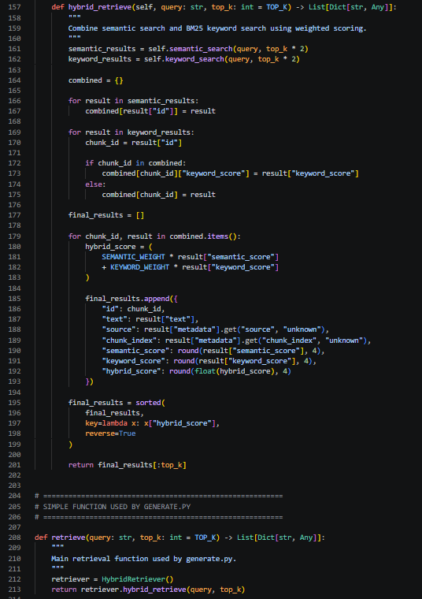
Figure 4: Hybrid weighted re-ranking and final retrieve function

7.4 LLM Generation and Prompt Design
The generation module is based on the Gemini 2.5 Flash model to generate the final output from retrieved context. The prompt template is strictly restricted to ensure that the model only uses the provided context and does not include information from its surroundings, exceptions, or invented article numbers, and, where possible, the name of the source documents. This is a significant RAG control as the task relates to legal information and parts of the information will have less reliability if it is not supported.

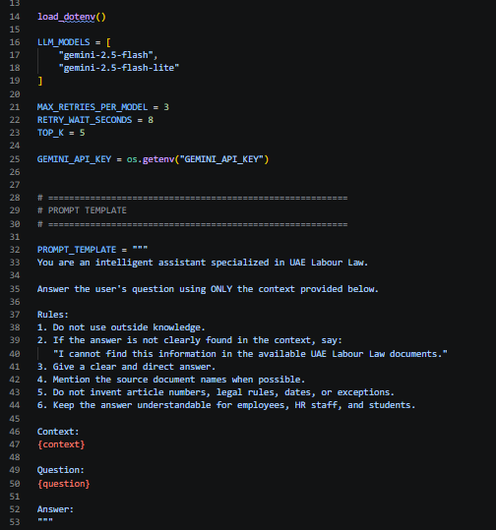
Figure 5: Gemini model configuration and prompt template

7.5 Context Formatting
Each retrieved chunk is represented as a structured evidence block, including the chunk number, source document, chunk index, hybrid score and chunk text, before the LLM is called. This adds more traceability as the model not only gets the actual text of the law, but also the source and the score of retrieval. The context is displayed in the prompt together with the users question, in the format used.

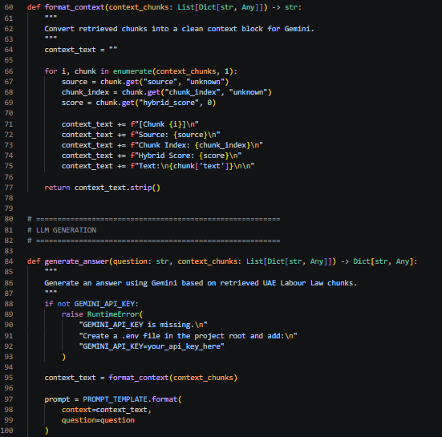
Figure 6: Formatting retrieved chunks into an evidence block

7.6 Reliability and Pipeline Flow
The generation function has an API key check and a retries mechanism built-in. If it receives temporary high-demand/rate-limit errors from Gemini, it will wait for 8 seconds and retry up to 3 times per model, but also has a fallback model to guarantee stability. The answer_question function forms the complete RAG pipeline: it retrieves the top five chunks, sends them to the generation function, and returns the answer, context chunks, selected model, and prompt used.

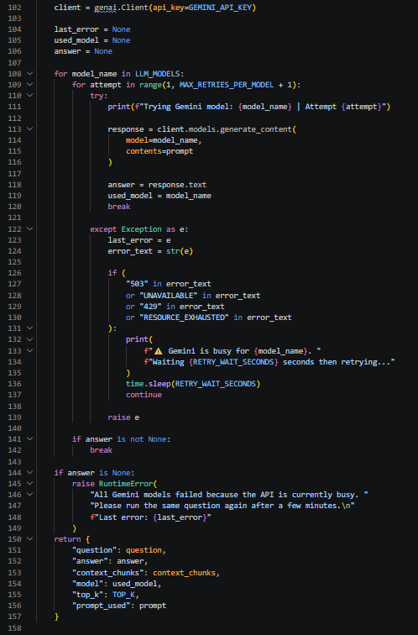
Figure 7: Gemini API call with retry and fallback handling
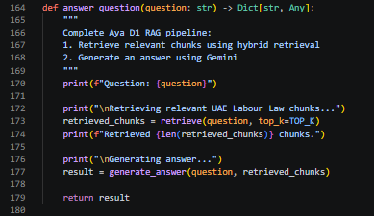
Figure 8: Full RAG pipeline function connecting retrieval and generation

7.7 Findings
Testing showed that the pipeline successfully loaded 2,033 ChromaDB chunks, retrieved five relevant chunks per question, and generated answers for all initial evaluation questions. A temporary Gemini 503 error occurred during one test but the retry mechanism handled it successfully. The main strength is that answers are grounded in retrieved legal evidence supported by source names and retrieval scores. The main limitation is that API availability can affect generation speed.

Finding Area | Result / Observation
Indexed chunks loaded | 2,033 chunks available in ChromaDB
Top-k retrieval | 5 chunks retrieved for each question
Retrieval strategy | Hybrid semantic search + BM25 keyword search
Generation stability | Retry and fallback logic handles temporary API demand
Observed limitation | Online API availability can temporarily delay answers

8. Web Interface & User Experience

UAE Labour Law Intelligent Assistant's web interface has been created using Streamlit, a high-performance framework that enables rapid-prototyping, has built-in session-state handling, and has minimal architecture overhead. With Streamlit, the end-to-end Retrieval-Augmented Generation (RAG) pipeline is able to communicate with the presentation layer directly, as it's not a separate front-end stack.

The application is deployed with an optimized dark theme and has been custom built with high quality dark theme by using custom CSS injections to give the application an enterprise grade responsive layout. The system is designed structurally in 4 major functional zones:

Dynamic Metrics Dashboard: An analytics bar at the top of the interface that tracks the health of the pipeline for the currently active session. It monitors cumulative number of processed user requests, total number of indexed source documents, total number of data fragments processed by the system (2,033 chunks) and live mathematical latency evaluation, monitoring the average response time of the engine.
Asymmetric Split-Panel Chat Interface: primary workspace is in two columns so that verification can be done immediately. The left side contains the conversational interface that is preserved from the state and users submit natural language compliance queries for it. A Document Evidence Matrix appears in the right panel that is dynamic. With each response generated, this matrix recall the information in the document, document source reference and calculated hybrid match rate (0.7 x Semantic Search + 0.3 x BM25) of the underlying text.

In addition to the Live Chat Interface, a dedicated Sample Queries tab provides pre-populated example legal situations (Leave & Gratuity, Employment Contracts, and Termination Rules) with interactive routing buttons, which make it easier to test these situations. In addition, a Pipeline Architecture & Logic tab visualizes the flow of the five-stage RAG execution, and also includes the actual Python code blocks controlling the hybrid rank fusion scoring formulas.

Collapsible System Configuration Sidebar: A status console that can be folded to the side. It features dynamic indicators that declare pipeline integrity (such as live key verification vs localized inference simulation), and logs all the extensive engineering parameters operating beneath them, with a clear view of the entire embedding model (all-MiniLM-L6-v2), the vector substrate (ChromaDB), and the Google Gemini 2.5 Flash LLM engine.

The “hallucination” problem is a fundamental weakness of LLMs, and incorporating the split-panel reference architecture alongside live hybrid confidence values is essential for countering this issue. The platform offers instant insight into the legal bits, thereby ruling out completely any risks of inference that are black-box. Users get full empirical support and establish a clear and auditable verification layer in the legal compliance domain, where they often have to traverse complicated institutional decrees.

9. Initial Evaluation

To evaluate the current performance of the UAE Labour Law Intelligent Assistant, an initial set of legal test questions was designed to cover multiple areas of UAE labour law including annual leave, termination, gratuity, working hours, maternity leave, labour complaints, remote work regulations, and employee rights.
Each question was submitted to the Retrieval-Augmented Generation pipeline in order to assess both retrieval quality and generated responses. During evaluation, the retrieved document chunks, generated answers, and system behaviour were manually reviewed to determine whether the assistant was capable of producing legally relevant and context-grounded responses.

Question | Retrieved Chunks Relevant? | Generated Answer Correct?
What is the minimum annual leave in the UAE? | Yes | Yes — 30 days stated correctly
When can an employer terminate without notice? | Yes | Yes — minor wording inconsistencies
What is end-of-service gratuity and how is it calculated? | Yes | Partially — calculation lacked detail
What are employee rights during probation? | Yes | Yes — no major issues
What is the maximum working hours per week? | Yes | Yes — no issues observed
What are the rules for maternity leave? | Yes | Yes — chunks highly relevant
What is the Wage Protection System (WPS)? | Yes | Yes — no issues observed
Can an employer reduce salary without consent? | Partially | Partially — limited direct legal reference
What are the rules for remote work in the UAE? | Yes | Partially — limited supporting documents
How does an employee file a labour complaint? | Yes | Yes — accurate procedural explanation

Table 1: Initial results of evaluation of UAE Labour Law Intelligent Assistant.

Evaluation Findings
The first evaluation showed that the RAG pipeline is able to extract legally relevant information with high semantic accuracy for several topics related to the UAE labour law. The system worked very well when it came to issues addressed in the gathered legal documents, like annual leave, working hours, maternity leave, labour complaints and termination rules.
Some questions that required specific calculations, policy interpretation or remote working policies, did return partially complete answers because not all documents were covered or there was not enough contextual information in the retrieved chunks. For a few instances, retrieval retrieved semantically related documents instead of exact legal clauses, reducing the precision of the retrieved documents.
The system architecture has been proved to be effective for supporting semantic retrieval and grounded legal question answering overall, with some limitations. Possible future directions of improvement are retrieval optimization, broader legal document coverage and chunking strategies and consistency of response generation.10. AI Usage Disclosure

Item | Details
AI tools used | Claude (Anthropic) was utilized in two ways: (1) To create the initial project plan and structure, such as the folder organization, task assignment and system architecture outline; (2) To generate the source code for all pipeline components (ingest.py, retrieval.py, generate.py, app.py). No other tools than mentioned above were used in AI.
Code written from scratch | The team did not write the pipeline code from scratch. However, each member was responsible for understanding, reviewing, testing, and adapting the code assigned to their component. These configuration parameters, file paths and minor fixes were done by hand by the respective team member.
Code adapted from sources | The code is developed with the help of Claude AI as according to the project needs. The code relies on the standard open-source libraries LangChain, Sentence Transformers, ChromaDB, Rank-BM25, Anthropic API and Streamlit, all of which are open-sourced.
What you don't fully understand | Advanced optimization techniques for large-scale retrieval systems and embedding performance tuning require further practical experimentation and research.

Full Name | Student ID
Alia Al Ali | 22000826
Salma | 22000895
Rana | 22000580
Aya | 22001387
Reem | 22001629

